**Using UNIX Basic Commands:**

1. To display the current working directory, the command is:

pwd

The output is as follows.

/home/trg1

1. Display the path to and name of your HOME directory.

echo $HOME

The output is as follows.

/home/admin

1. Display the login name using which you have logged into the system

Whoami

The output is as follows.

admin.

1. Display the hidden files of your current directory.

ls -a.

1. List the names of all the files in your home directory.

ls ~

The output is as follows.

Desktop Documents Downloads Music Pictures Public Templates Videos.

1. Using the long listing format to display the files in your directory.

ls -l OUTPUT

admin@hostname01 Desktop]$ touch abc.txt

[admin@hostname01 Desktop]$ touch def.txt

[admin@hostname01 Desktop]$ touch swap.text

[admin@hostname01 Desktop]$ touch shai.txt

[admin@hostname01 Desktop]$ rm swap.text

[admin@hostname01 Desktop]$ touch swap.txt

[admin@hostname01 Desktop]$ ls -l

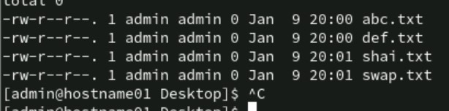

For my reference

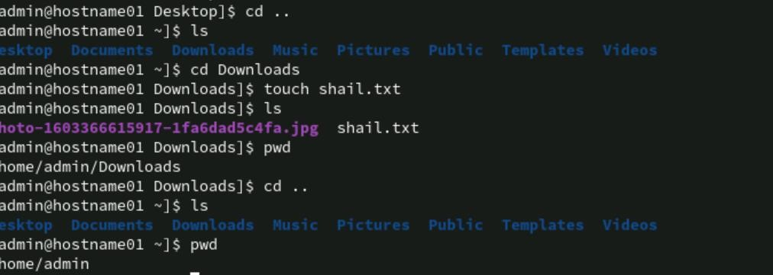

1. List the files beginning with chap followed by any number or any lower case alphabet. (Example , it should display all files whose names are like chap1, chap2, chap3 ……., chapa,ahapb,chapc,……..)

touch chap1 chap2 chapa chapb ls chap[0-9a-z]

output chap1 chap2 chapa chapb.

1. Give appropriate command to create a directory called C_prog under your home directory. (Note: Check the directory using ls )

mkdir ~/C_prog

ls ~

output:-

C_prog Desktop Documents Downloads Music Pictures Public Templates Videos.

1. Create the following directories under your home directory. (Note: Check using ls newdir newdirectory ). mkdir ~/newdir mkdir ~/newdirectory.

Ls ~.

Output:

C_prog Desktop Documents Downloads Music newdir newdirectory Pictures Public Templates Videos.

1. List the names of all the files, including the contents of the sub directories under your home directory.

ls -R ~ output:

/home/admin:

C_prog Desktop Documents Downloads Music newdir newdirectory newl1 Pictures Public Templates Videos

/home/admin/C_prog:

/home/admin/Desktop:

abc.txt def.txt shai.txt swap.txt

/home/admin/Documents: chap1 chap2 chapa chapb

/home/admin/Downloads:

photo-1603366615917-1fa6dad5c4fa.jpg shail.txt

/home/admin/Music:

/home/admin/newdir:

/home/admin/newdirectory:

/home/admin/newl1:

/home/admin/Pictures:

/home/admin/Public:

/home/admin/Templates:

/home/admin/Videos:

1. Remove the directory called newdirectory from your working directory.

rmdir ~/newdirectory

Output:-

ls ~

C_prog Desktop Documents Downloads Music newdir newl1 Pictures Public Templates Videos

1. Create a directory called temp under your home directory.

mkdir ~/temp Output

ls ~

C_prog Desktop Documents Downloads Music newdir newl1 Pictures Public temp Templates Videos

1. Remove the directory called newdir under your home directory and verify above with the help of the directory listing command.

rmdir ~/newdir

ls ~

C_prog Desktop Documents Downloads Music newl1 Pictures Public temp Templates Videos.

1. Create another directory directory new under the temp directory.

mkdir ~/temp/directorynew ls ~/temp

output directorynew

1. Change the directory to your home directory.

Cd ~ ->Moves you to your home directory.

1. From your home directory, change the directory to directorynew using relative and absolute path. Using Relative path :-cd temp/directorynew using absolute path:- cd ~/temp/directorynew

[admin@hostname01 directorynew]$

1. Remove the directory called c_prog, which is in your home directory. rm -r ~/C_prog rmdir?

Desktop Documents Downloads Music newl1 Pictures Public temp Templates Videos

1. Change to the directory /etc and display the files present in it. cd /etc

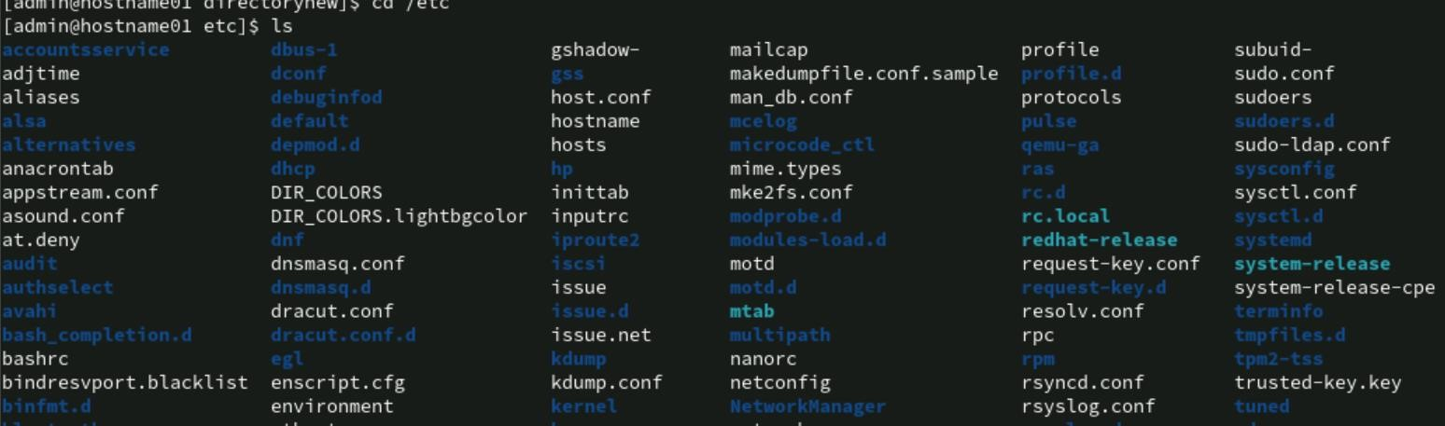

1. List the names of all the files that begin with a dot in the /usr/bin directory.

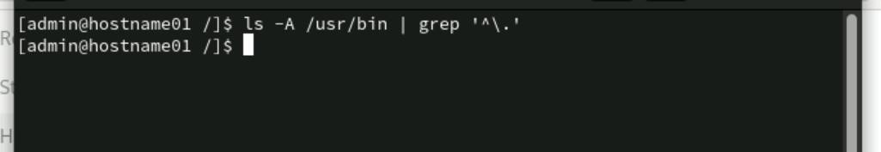

1. Create a file first.unix with the following contents.

Hi! Good Morning everybody.

Welcome to the First exercise on UNIX.

Hope you enjoy doing the assignments.

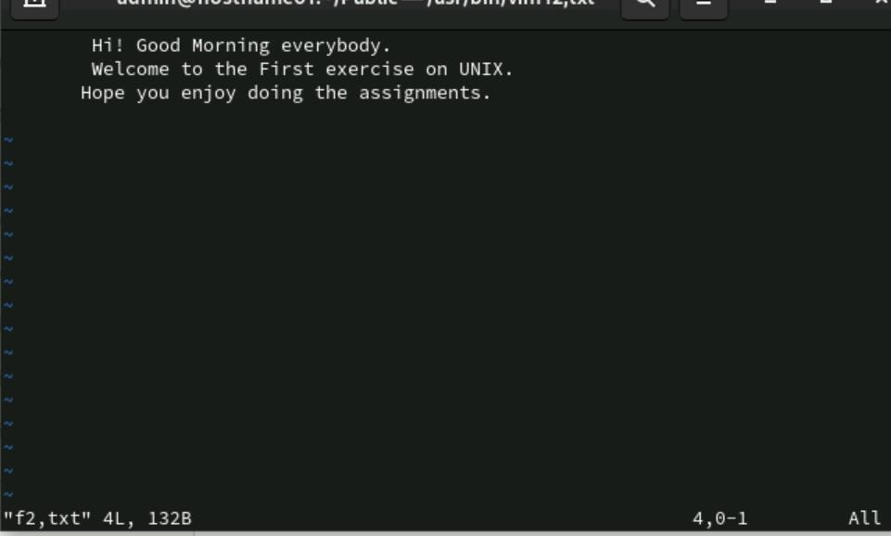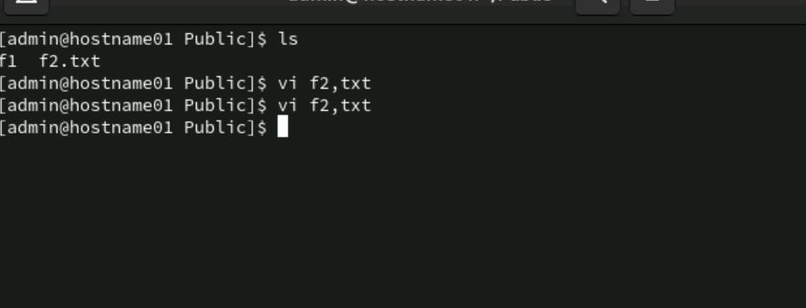

->:WQ->SAVE AND EXIT

:W->SAVE. U->UNDO, dd->delete.

1. Copy the file first.unix in your home directory to first.unics.

(Note: checked using ls, first.unix file also should exist along with first.unics)

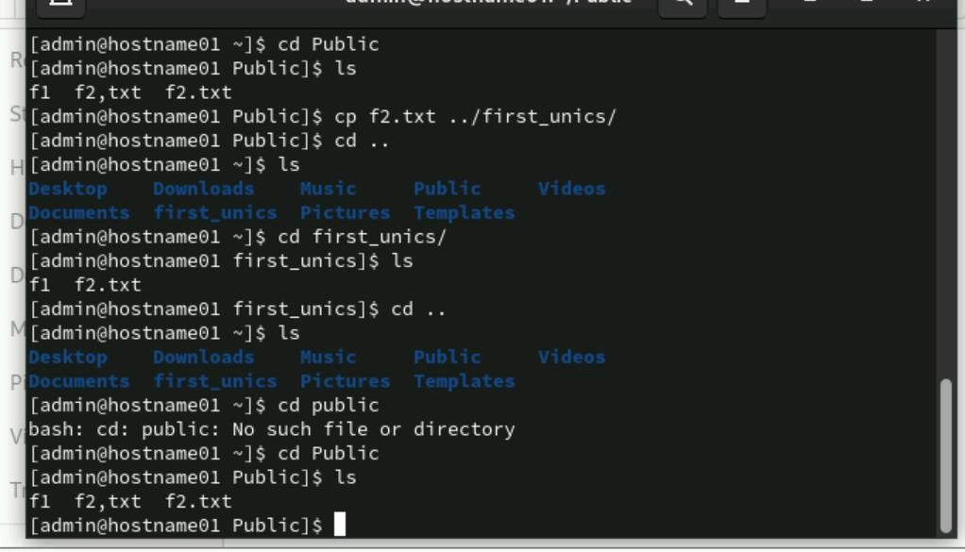

1. List the contents of first.unix and first.unics with a single command.

1. Create a new directory under the temp directory.

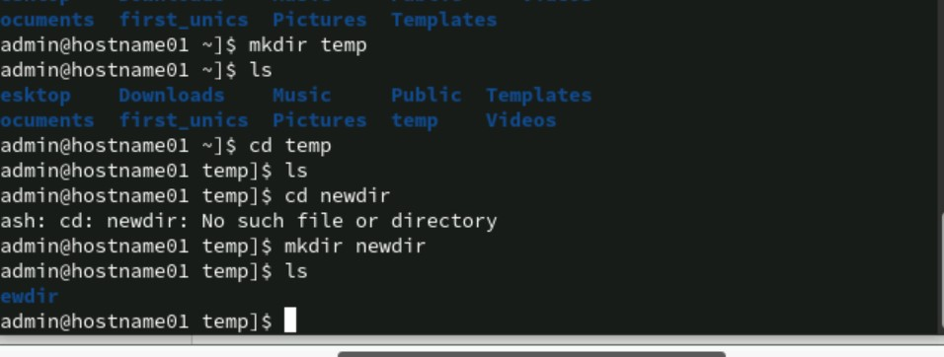

1. From your home directory, copy all the files to the directory created under the temp sub directory.

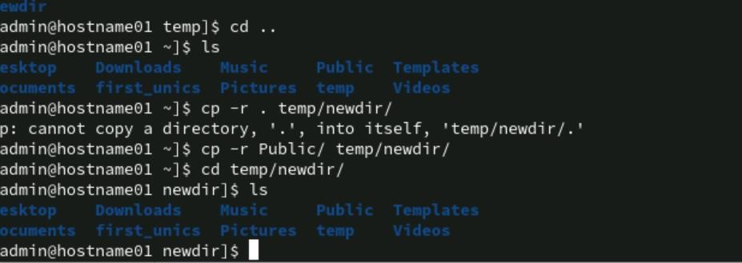

1. Move the file first.unix to the directory temp as second.unix

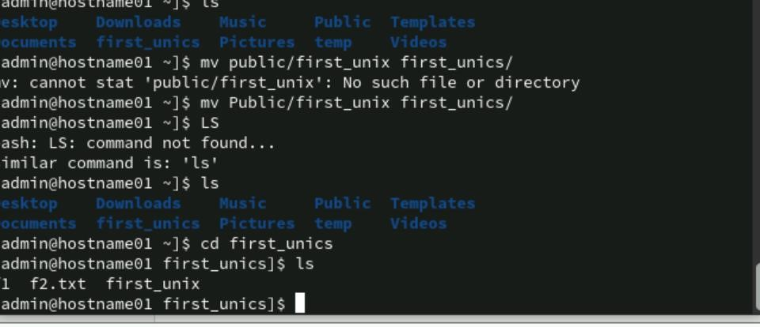

1. Remove the file called first.unics from the home directory.

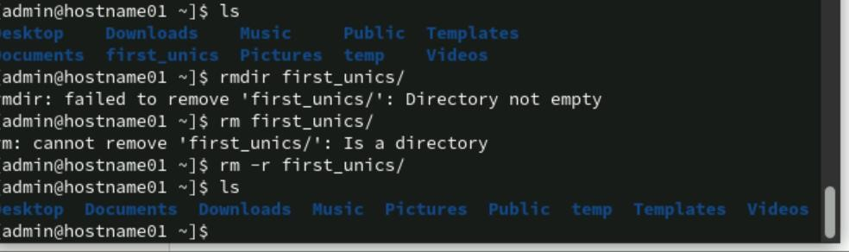

1. Change your directory to temp and issue the command rm *. What do you observe?

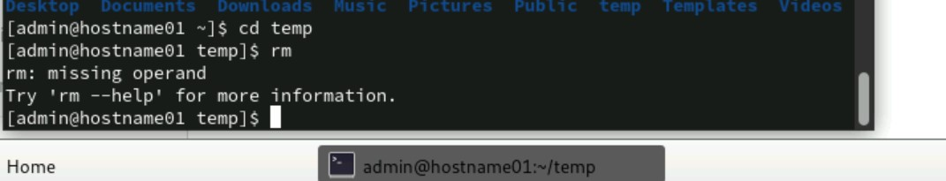

The rm command requires arguments(files or directory names )to delete .If no arguments are provided ,the system will display message like

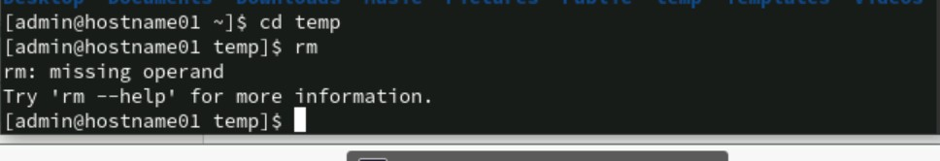

1. Move all files whose names end with a, c and o to the HOME directory.

1. Copy all files that end with a ‘UNIX’ to the temp directory.

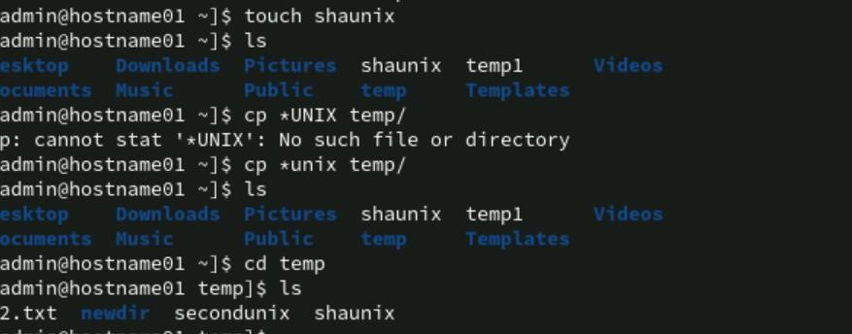

1. Issuing a single command, remove all the files from the directory temp and the

directory itself.

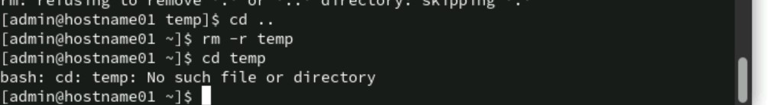

1. Try commands cp and mv with invalid number of arguments and note the results.

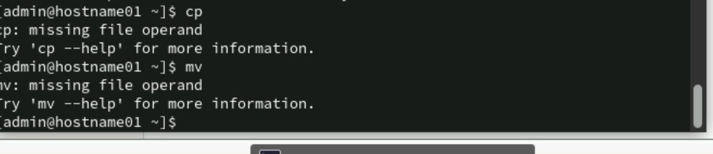

Both command will show error message indicating that arguments are missing .

1. Use the cat command to create a file friends, with the following data:

Madhu 6966456 09/07/68

Jamil 2345215 08/09/67

Ajay 5546785 01/04/66

Mano 7820022 09/07/68

David 8281292 09/09/60

Simmi 7864563 12/12/70

Navin 2224311 30/05/68

The fields should be separated by a tab.

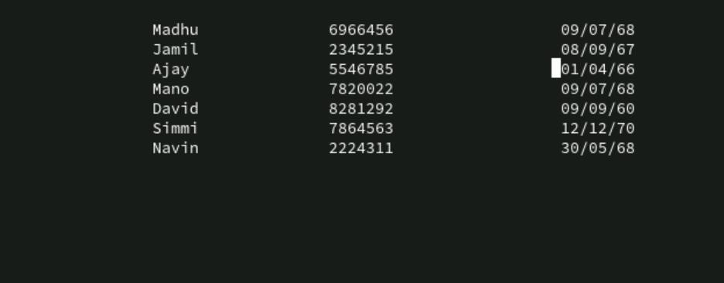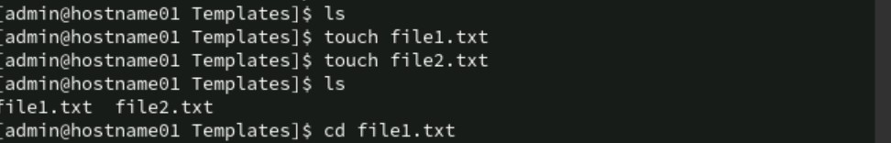

Another method:

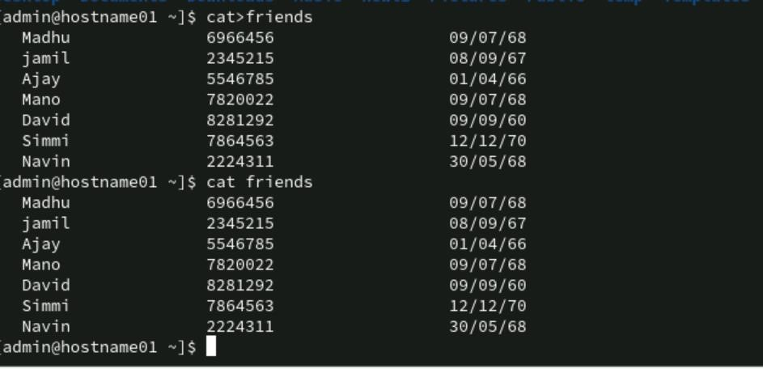

1. Display contents of the file friends.



1. Copy contents of friends to newfriend without using the cp command.

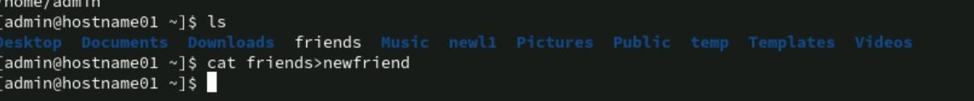

1. Display contents of the file friends and newfriends in a single command.

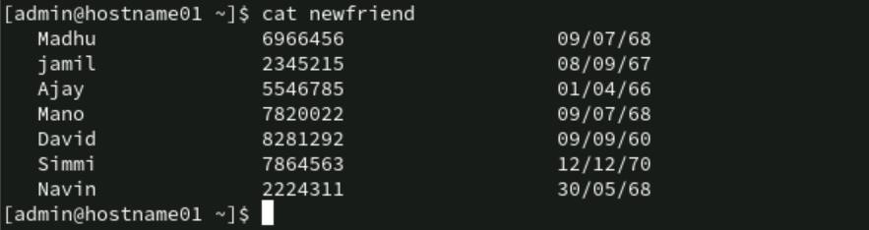

1. Find all users currently working on the system and store the output in a file named

as users.

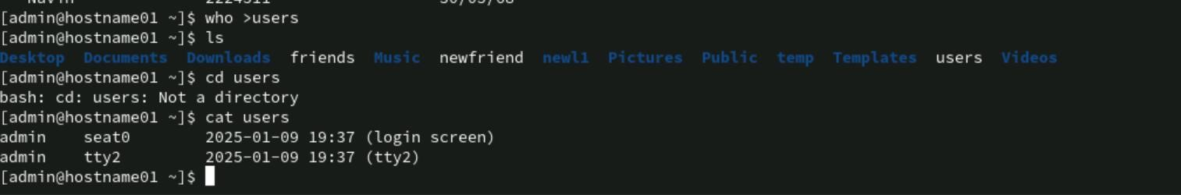

1. Append contents of friends file to the file, users.

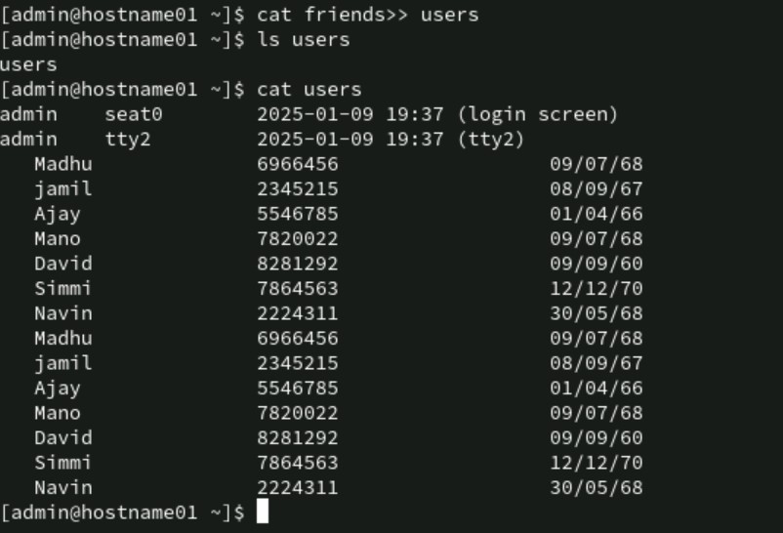

1. Display current system date and time and record your observations. How is the time displayed?

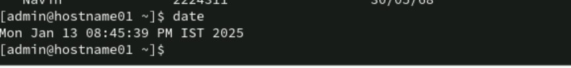

1. Display calendar for the month and year of your birth.

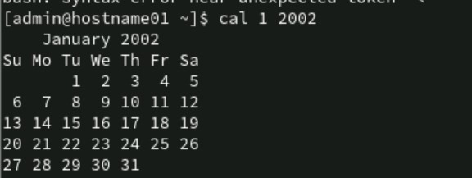

1. Try following commands and record your observations.

date “+ %” -> This will o/p % as literal character because % is to specify specifiers ,but there is no valid format for this.

date “+%m” -> This will display current month as two-digit number for exam current month is jan it will display 01. date “+%D” -> This will display date in the format MM/DD/YY.

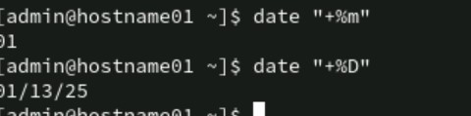

date “+%/%Training Activity”

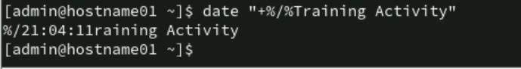

This will o/p as literal string because there is no valid format , The command will interpret it literally. date “+%r”



This will return time in 12 hr format within Am-pm suffix.

Using Pipes and Filters:

1: Redirect the content of the help document ls, into a file called as ls doc.



2: Display the content of the lsdoc page wise.

->less Isdoc

->more Isdoc

3: Create a file data.txt using input redirection.

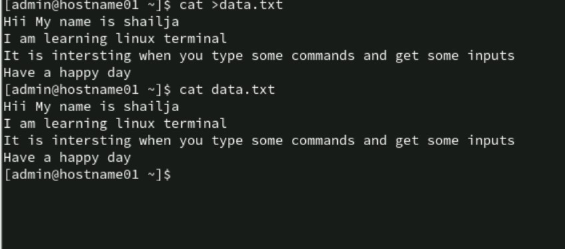

4: Display data.txt.

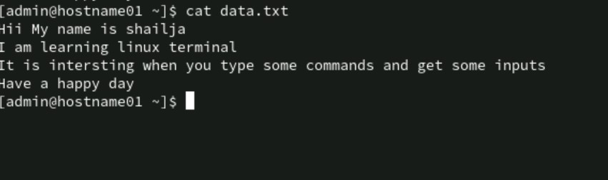

5: Remove the file data.txt.



6: Use error redirection to display data.txt, if any error stores it in errorlog.txt

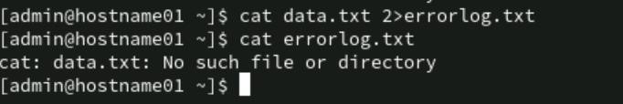

7: Display errorlog file.

